**DAILY ONLINE ACTIVITIES SUMMARY**

|  |  |  |  |  |  |  |
| --- | --- | --- | --- | --- | --- | --- |
| **Date:** | | **23 June 2020** | | **Name:** | **KHATHEEJA SAFREENA.** | |
| **Sem & Sec** | | **4th sem, 2nd year** | | **USN:** | **4al18cs037.** | |
| **Online Test Summary** | | | | | | |
| **Subject** | **---------** | | | | | |
| **Max. Marks** | **----** | | **Score** | | **---** | |
| **Certification Course Summary** | | | | | | |
| **Course** | | **INTRODUCTION TO R.** | | | | |
| **Certificate Provider** | | **GreatLearning** | **Duration** | | | **5 hours** |
| **Coding Challenges** | | | | | | |
| **Problem Statement:1 program** | | | | | | |
| **Status: Executed** | | | | | | |
| **Uploaded the report in Github** | | | **Yes** | | | |
| **If yes Repository name** | | | [http://shafreenasharief / lockdown-coding](http://shafreenasharief / lockdown-coding" \o "http://shafreenasharief / lockdown-coding)  [http://shafreenasharief / locked-down--certification-course](http://shafreenasharief / locked-down--certification-course" \o "http://shafreenasharief / locked-down--certification-course)  **[http://shafreenasharief / Daily\_Report](http://shafreenasharief / Daily_Report" \o "http://shafreenasharief / Daily_Report)** | | | |
| **Uploaded the report in slack** | | | **Yes** | | | |

**Certification Course Details: (Attach the snapshot and briefly write the report for the same)**

**Coding Challenges Details: (Attach the snapshot and briefly write the report for the same)**

**CERTIFICATION COURSE SUMMARY:**

Today I started new course **INTRODUCTION TO INFORMATION R** through **GREAT LEARNING** the course is secluded for 6hrs. After the completion of course, certificate will be provided. I completed all the module .I attempted quiz ,which gave me a clear veiw about the topics that were thought and discussed.It consists of 7 modules which also include assessments.

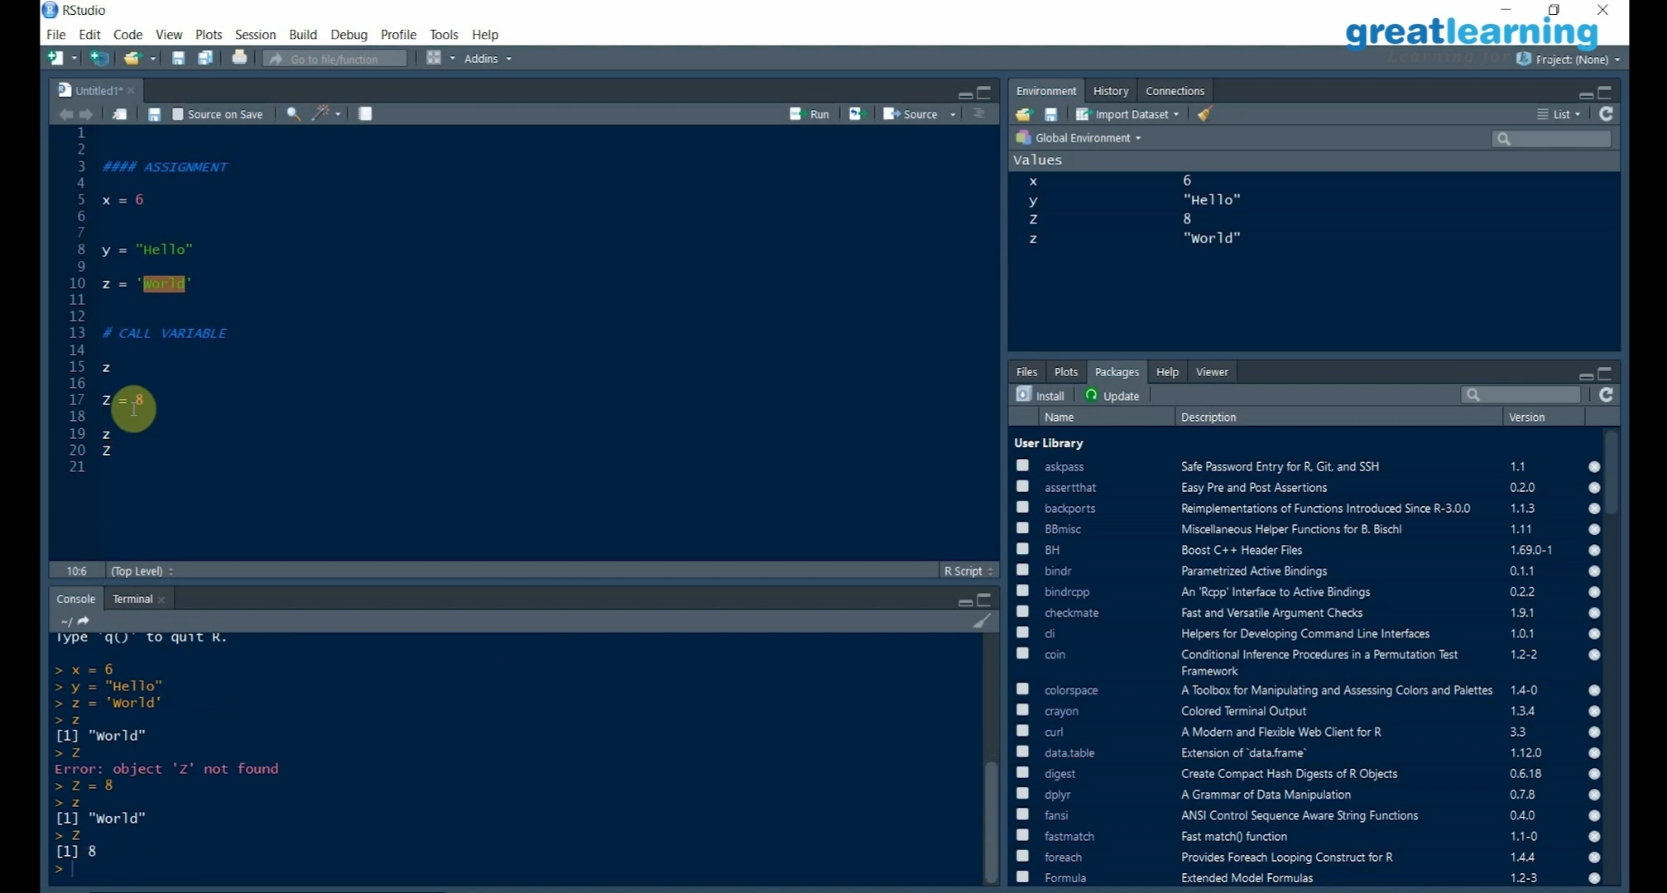

Today I solved 1 coding challenge,

1. **Python Program to Split the array and add the first part to the end There is a given an array and split it from a specified position, and move the first part of array add to the end.**

Examples:

Input: arr [] = {12, 10, 5, 6, 52, 36}  
 k = 2  
 Output: arr [] = {5, 6, 52, 36, 12, 10}  
 Explanation: Split from index 2 and first  
part {12, 10} add to the end.

Input: arr [] = {3, 1, 2}  
k = 1  
Output: arr [] = {1, 2, 3}  
Explanation: Split from index 1 and first  
part add to the end.

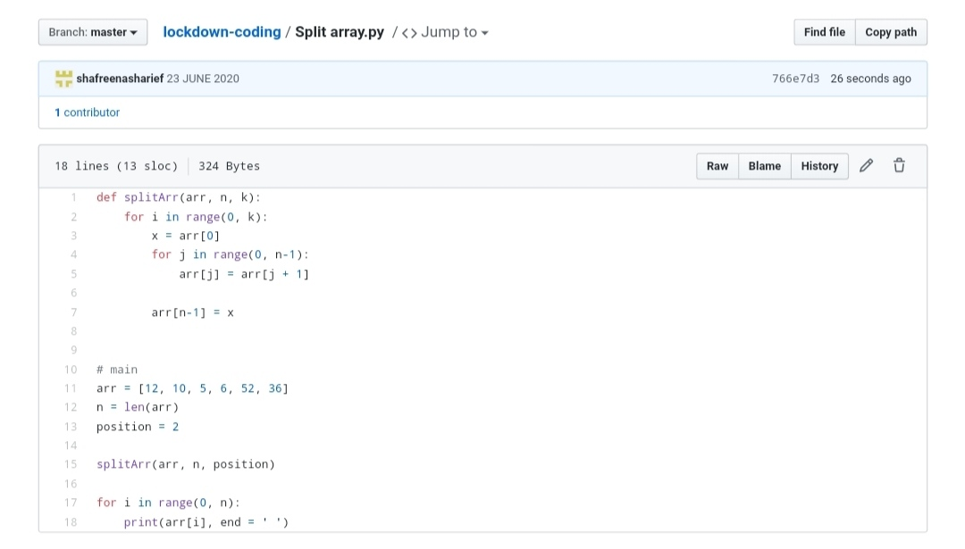

***EXTRA ACTIVITIES:***

Today I attended IoT webinar conducted by Alva’s Institute of Engineering and Technology for 2 hours.

Which explains deep about IoT, what is IoT and different type of sensors, Application of sensors, about Arduino board and applications, Installation and etc.

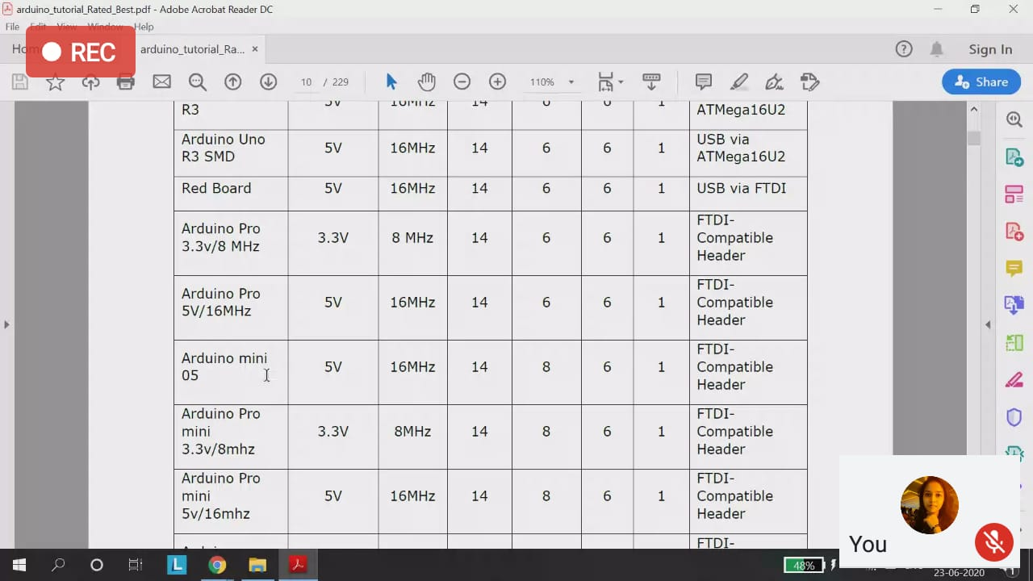

*ONLINE TEST OF IOT:*

After attending IoT webinar I also attended exam conducted on IoT which is of 20 min for 15 marks.

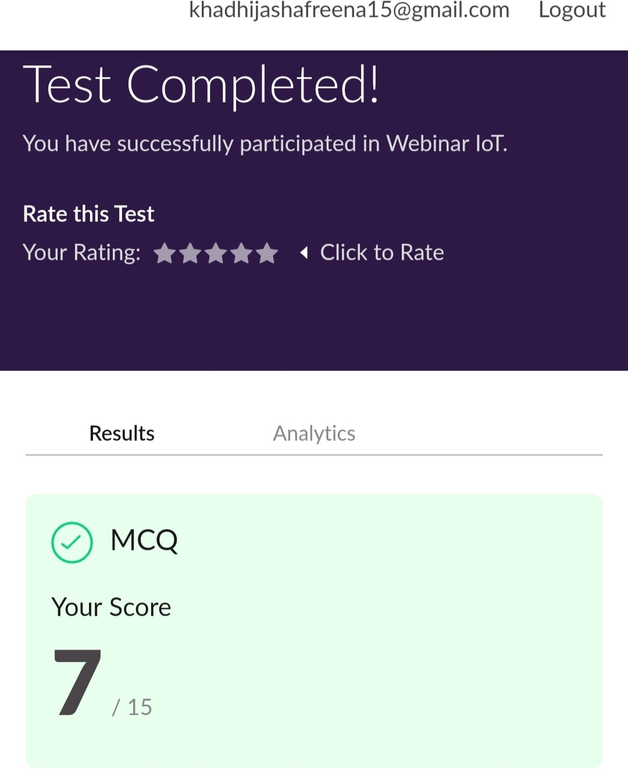

**SOLUTION** : I have uploaded the solution of the above coding problems in my GitHub repository.

[http://shafreenasharief / lockdown-coding](http://shafreenasharief / lockdown-coding" \o "http://shafreenasharief / lockdown-coding)

[http://shafreenasharief / locked-down--certification-course](http://shafreenasharief / locked-down--certification-course" \o "http://shafreenasharief / locked-down--certification-course)

[http://shafreenasharief / Daily\_Report](http://shafreenasharief / Daily_Report" \o "http://shafreenasharief / Daily_Report)